**Install SQL Server**

Run the downloaded EXE as Administrator

Right click on Exe and Run as Administrator

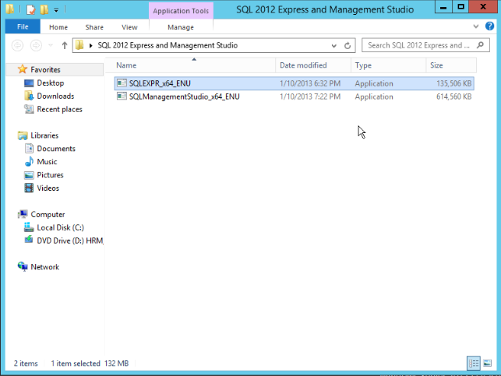

Click the **New SQL server stand-alone installation**

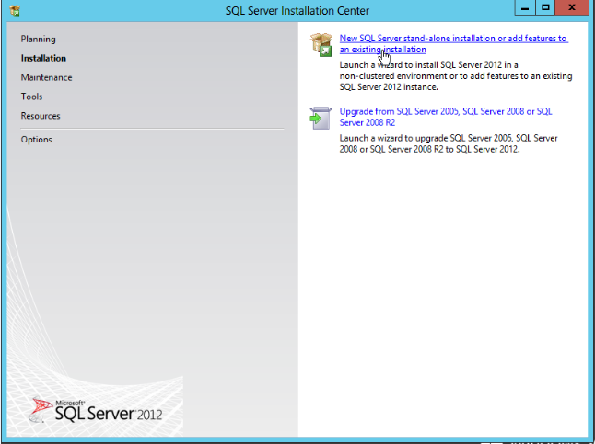

Select accept the license and click next

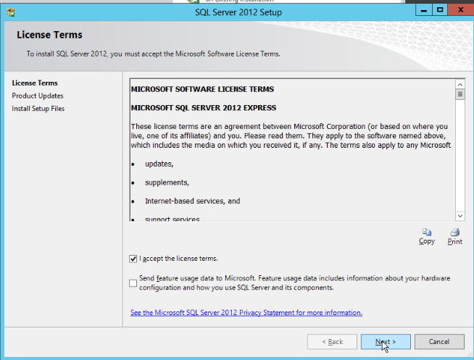

Click Next (You should be connected to internet for downloading the required files from Microsoft Server)

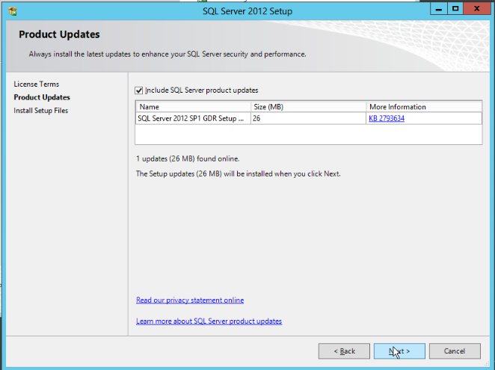

It will connect to internet and download and install

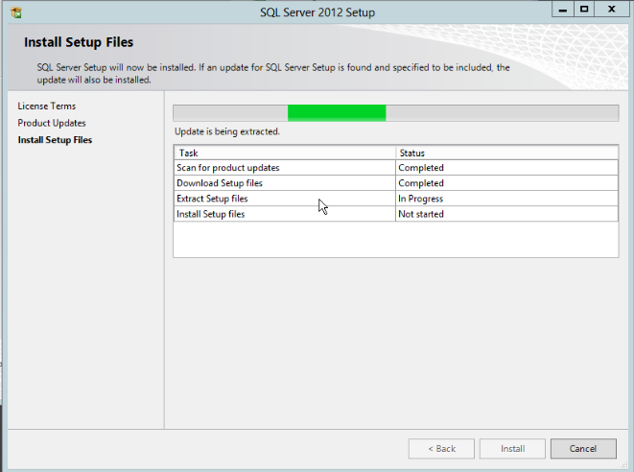

Select all features and click next

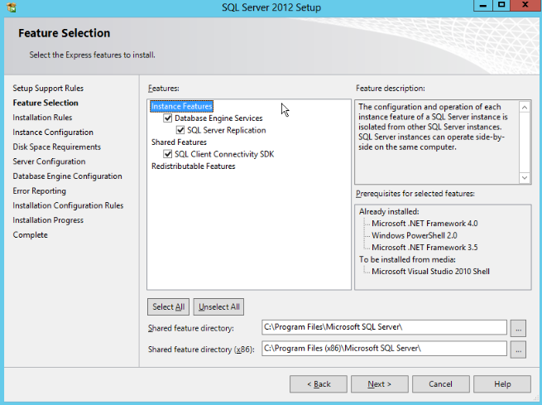

Select the Named instance and enter name and click next

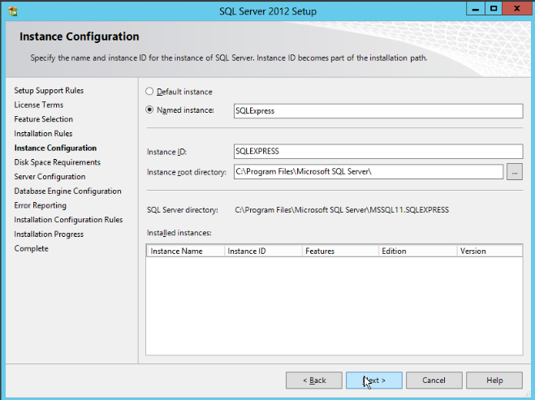

Click next

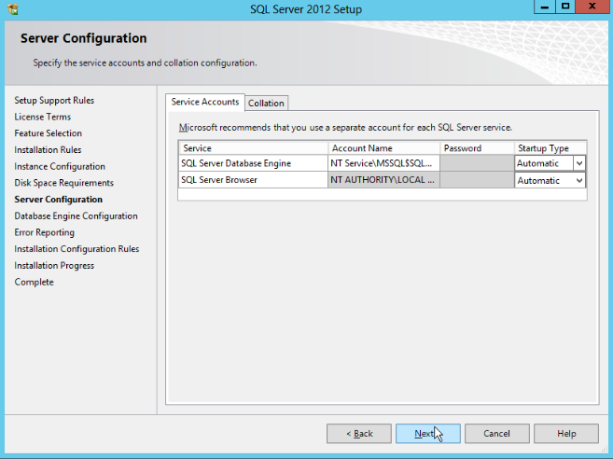

Select Mixed Mode and enter the password for administrator “sa”

Click on Add Current User Button.

Click Next

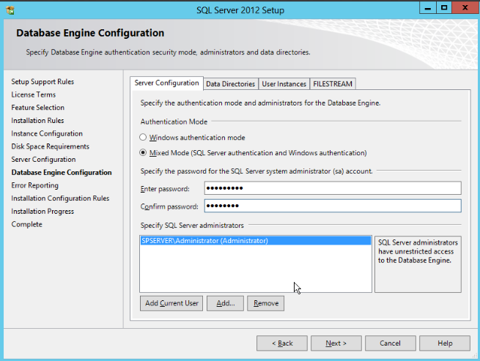

Click Next

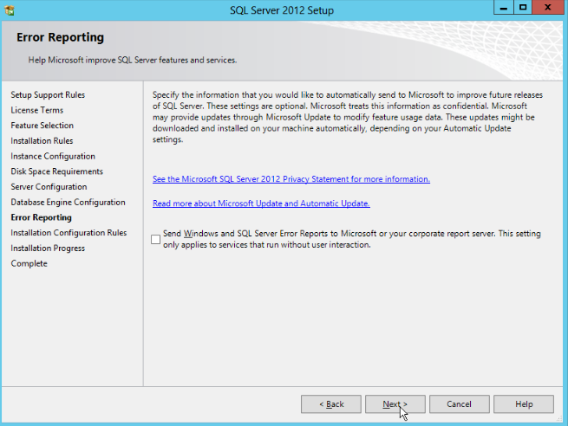

Start the installation progress

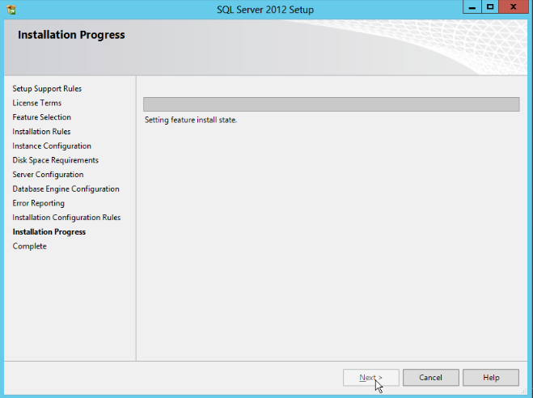

Complete Installation click Close

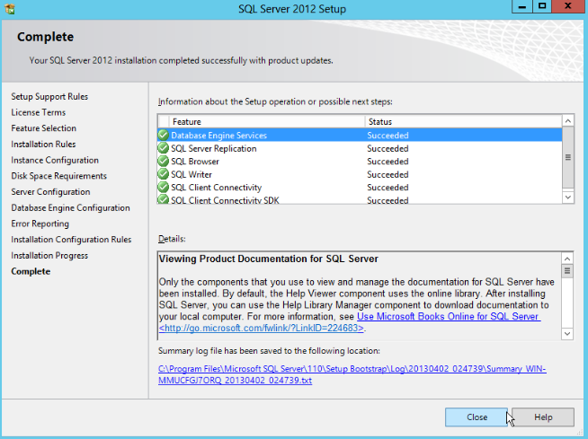

Install **SQL Server Management Studio (OPTIONAL)**

Right click on SQLManagementStudio_x64_ENU and Select Run as Administrator

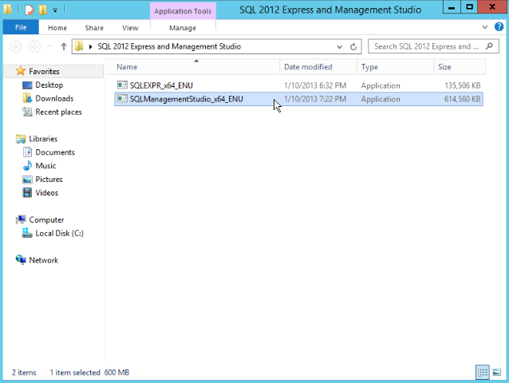

Click the **New SQL Server stand-alone installation**

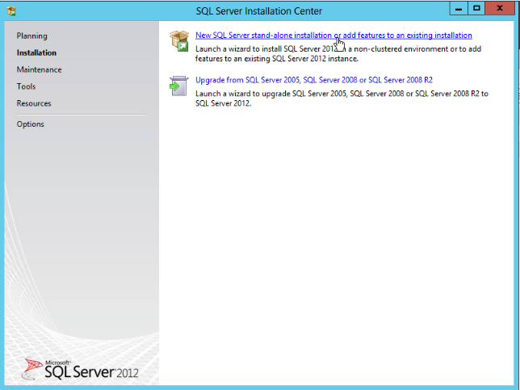

Automatically downloaded from internet update patch

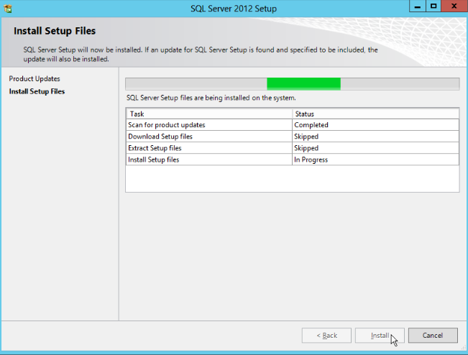

Select add features to an existing instance of sql sever 2012

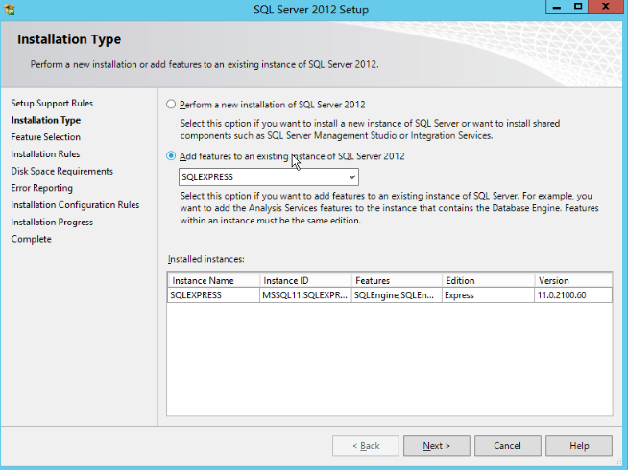

Select all features and click next

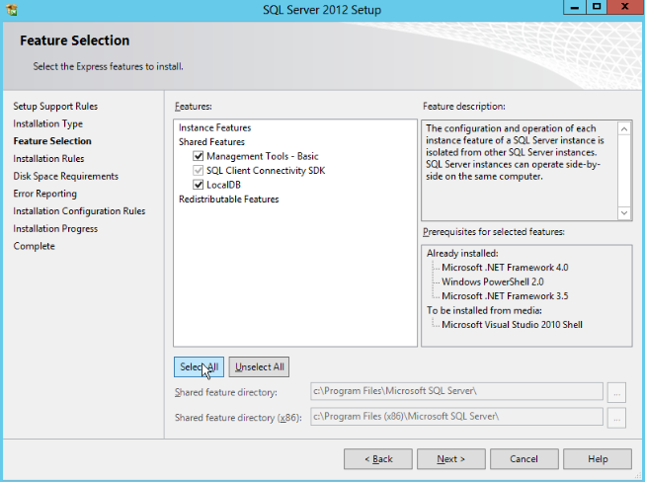

Click next

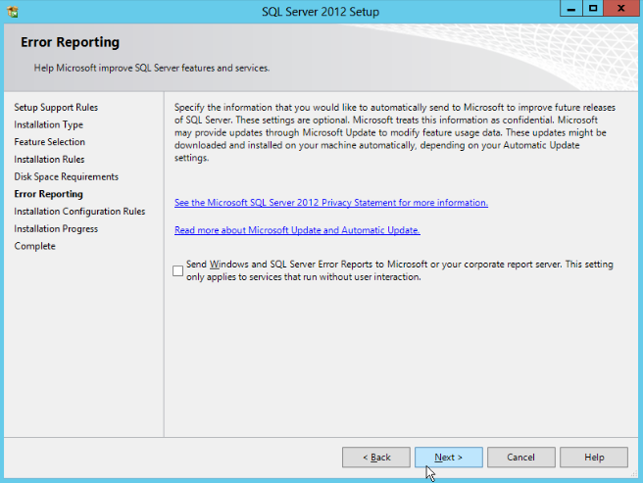

Close window after complete the installation

